Visualization #1: Shows distribution of distinct orders where the unit price was $100 or more

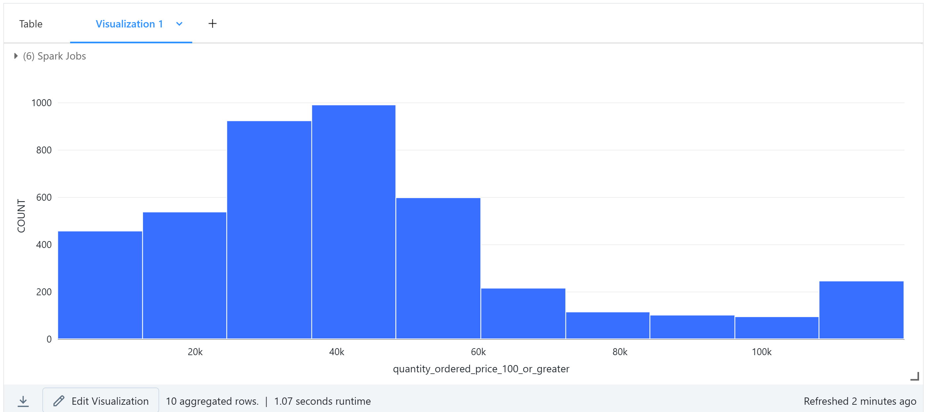Visualization #2: Shows how many orders are in each stage of status